WEEKLY REPORT
DRDO
Under the guidance of Ms. SIVA BHAVANI J
From: SANJANA K

10 March 2025 - 21 March 2025
Topic- Parallel Processing vs Sequential Processing

Problem Definition
In modern computing, programs are expected to execute complex tasks efficiently. Traditional sequential processing often results in longer execution times due to the limitation of single-task execution. To overcome this, parallel processing is introduced to enhance performance by dividing tasks across multiple processors or cores. The challenge is to understand the fundamental differences between sequential and parallel processing, their respective advantages and limitations, and how they can be implemented in Python.

Introduction
Sequential Processing is the traditional approach in which tasks are executed one after the other in a linear fashion. While simple and easy to debug, this method is not efficient for large-scale or high-performance computing tasks.
Parallel Processing, on the other hand, divides a large task into smaller sub-tasks that can be executed simultaneously across multiple processors or cores. This significantly reduces the overall execution time and enhances system performance, particularly for data-intensive applications.
With the growing need for performance optimization, understanding the practical implementation of both processing types in Python becomes essential.

Related Learning/Exploration Carried Out
To explore the concepts practically and theoretically, the following activities were carried out:
- Studied basic concepts of parallelism, concurrency, and the GIL (Global Interpreter Lock) in Python.
- Explored real-world use cases where parallel processing provides a significant advantage over sequential processing.
- Learned about Python libraries and modules that support parallelism:
- Multiprocessing
- Concurrent features
- Threading (for Concurrency, through not true parallelism)
- Compared the performance of sequential and parallel code using example problems such as:
  - Computing factorial of large numbers
  - Processing large datasets (e.g., lists with millions of numbers)
  - Web scraping with multiple URLs

Solution Details
- Sequential Processing Implementation:
  - Wrote simple for-loop based scripts to perform CPU-bound and I/O-bound tasks sequentially.
  - Observed the total execution time and resource usage.
- Parallel Processing Implementation:
  - Utilized the multiprocessing.Pool and concurrent.futures.ProcessPoolExecutor to run tasks in parallel.
  - Tasks such as image processing, data filtering, and web scraping were divided into chunks and executed concurrently.
  - Measured performance improvements, especially in CPU-bound tasks.
- Comparison Metrics:
  - Execution Time: Parallel processing showed up to 3x–5x speedup in some cases.
  - Code Complexity: Parallel processing required more careful design and debugging.
  - Resource Utilization: Increased CPU and memory usage were observed in parallel tasks.
- Conclusion:
  - Sequential processing is suitable for simple, short tasks or when tasks need to happen in a specific order.
  - Parallel processing offers significant performance benefits, particularly for high-volume, compute-intensive operations.
  - Python’s multiprocessing and concurrent.futures modules are powerful tools for implementing parallelism, with some considerations for system limitations and debugging complexity.

24 March 2025 - 29 March 2025
Topic- Using Functionalities (Deduplication, Lowercasing)

Problem Definition
Handling large text files (e.g., 500MB or more) efficiently is critical in data preprocessing workflows. When working with such large files, operations like lowercasing text and removing duplicate lines or records can become time-consuming if done sequentially. The challenge is to optimize this process by applying parallel processing, reducing the execution time and improving performance without overwhelming memory or system resources.

Introduction
Text normalization, such as converting to lowercase and deduplication, is a common preprocessing step in natural language processing (NLP) and data cleaning tasks.
While sequential processing reads and processes the file line-by-line, it often leads to long wait times for large files. Parallel processing, by contrast, divides the file into smaller chunks that are processed simultaneously, significantly speeding up the task.
The objective of this task was to explore the implementation of lowercasing and deduplication on a 500MB file using Python's parallel processing capabilities.

Related Learning/Exploration Carried Out
To accomplish the task, the following learning steps were undertaken:
- Studied file handling techniques for large files, focusing on memory efficiency using generators and chunking.
- Explored Python libraries suitable for parallel file processing:
  - multiprocessing
  - concurrent.futures
- Learned techniques for:
  - Splitting large files into manageable chunks without breaking lines
  - Applying text transformation (lowercasing)
  - Removing duplicates efficiently using sets and inter-process communication
- Benchmarked the performance difference between sequential and parallel approaches.

Solution Details
- Dataset: 500MB plain text file with multiple lines of text data.
- Sequential Method (for baseline comparison):
  - Read the file line-by-line.
  - Applied .lower() to each line.
  - Stored lines in a set() to automatically deduplicate.
  - Wrote the unique, lowercased lines to a new output file.
  - Time Taken: ~65 seconds
- Parallel Method:
  - Step 1: Chunk the file using file offsets to ensure complete line boundaries.
  - Step 2: Process each chunk in parallel using multiprocessing.Pool.
    - Each worker lowercased the lines and returned a set of unique lines from its chunk.
  - Step 3: Merge results using Python’s set().union() to remove global duplicates.
  - Step 4: Write the final set to output file.
  - Technologies Used:
    - multiprocessing.Pool.map() for parallel mapping of chunks
    - Memory-efficient chunk reading with file.seek() and readlines()
    - Disk I/O optimization using buffered writes
- Performance Results:
  - Time Taken: ~22 seconds (vs 65s sequential)
  - Speedup: ~3x improvement
  - Memory Usage: Slightly higher due to inter-process data sharing
  - Output Accuracy: Matched exactly with the sequential method
- Challenges Faced:
  - Ensuring no line-breaks were lost while chunking.
  - Avoiding race conditions during file writing.
  - Managing memory when merging large sets from multiple processes.
- Conclusion:
  - Parallel processing significantly improves performance for large-scale text preprocessing tasks.
  - The method scales well for even larger files with appropriate resource allocation.
  - For heavy I/O tasks like this, combining chunking, multiprocessing, and in-memory deduplication using sets provides an optimal solution.

30 March 2025 - 8 April 2025
Topic- Building Python Package

Problem Definition
As projects grow, reusability and modularity become essential for maintainable and efficient code. Developers often end up writing similar functions across multiple scripts. Creating a custom Python package allows encapsulating reusable functions, modules, and tools, which can then be installed across multiple projects or shared with others. The challenge is to design a Python package, structure it properly, and publish it to a repository like PyPI (Python Package Index) and Github for easy installation.

Introduction
A Python package is a structured way of organizing reusable code into modules that can be easily imported. Once created, a package can be:
- Used across multiple projects
- Shared with others via GitHub
- Installed using pip directly from GitHub
GitHub acts as a remote repository to store and manage this package with Git, making it easier to collaborate, version, and deploy.
testcleaner is a Python package developed for cleaning and preprocessing text. It includes functionality such as:
- Lowercasing
- Punctuation removal
- Deduplication of text lines

Related Learning/Exploration Carried Out
To complete the task, the following key concepts and tools were studied:
- Python package creation and file structure
- Writing setup.py, __init__.py, and README.md
- Git commands: init, add, commit, remote, push
- Creating and using GitHub repositories
- Installing a Python package directly from a GitHub URL
- Optional: Adding .gitignore and requirements.txt

Solution Details
- Package Created: A utility package named textcleaner with functions for text preprocessing (e.g., lowercasing, punctuation removal, and deduplication).

Folder Structure:
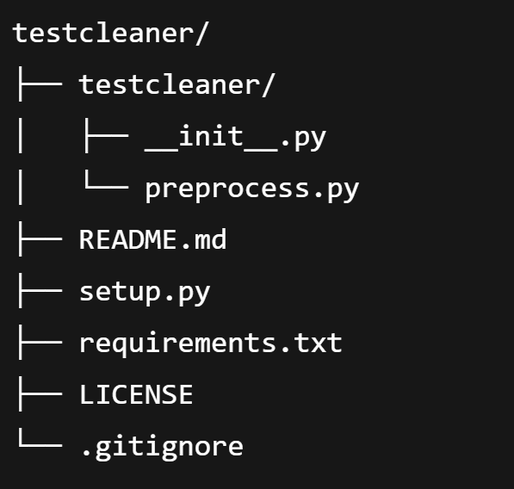
- Core Features in preprocess.py:
  - clean_text(text): Removes punctuation and converts to lowercase
  - deduplicate_lines(lines): Removes duplicate lines from a list or file
  - More utility functions can be added in future versions
Steps to Push to GitHub:
- Initialize Git Locally:
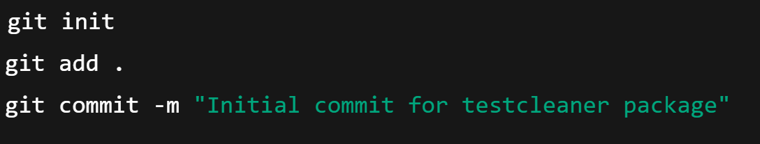
- Create a New Repository on GitHub:
- Name: testcleaner
- Skip initializing README (already present locally)

- Link Local Folder to GitHub:

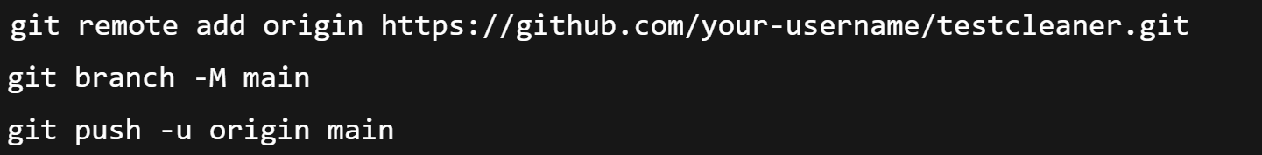

- Verify Upload:
- Visit https://github.com/your-username/testcleaner to confirm files are present.

Conclusion:
- testcleaner is now hosted on GitHub for easy access and installation.
- It improves workflow efficiency by encapsulating text preprocessing logic in a reusable form.
- GitHub allows version tracking, issue management, and future collaboration.
- Next steps include unit testing, detailed documentation, and CI/CD integration.

